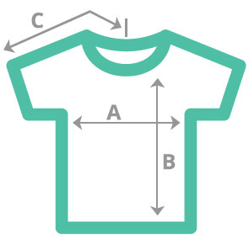

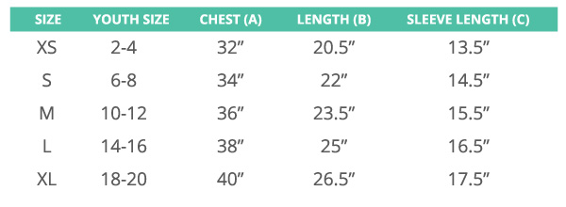

**Youth Sizing Chart**

*\*Sizing based on the* ***Gildan 5000B*** *t-shirt*

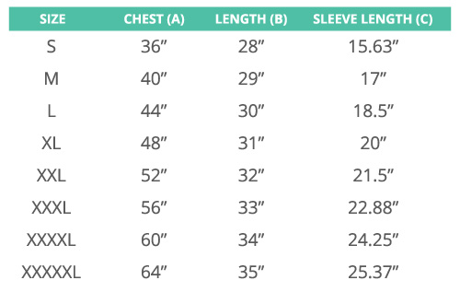

**Adult Sizing Chart**

*\*Sizing based on the* ***Gildan 5000*** *t-shirt.*